Project 5 Report Template — Transformer Grokking
| Submission: This report + code + README

Field | Value
Team name | Sreeya
Member 1 | Sreeya Malgani

1. Team Information

- Team name (optional):Sreeyakethanajaini
- Member 1: Sreeya Malgani

2. Contributions
Describe each member’s contributions (experiments, coding, writing, analysis).
Member | Contributions
Sreeya Malgani | Model setup (model.py), train.py, inference.py, sanity checks (Part 1.5)
Data generation (Part 2.1), Part 2.2 experiments, results analysis and plots
Part 2.3 grokking experiments, Part 2.4 ablation study, report writing

3. Environment & Reproducibility
- Hardware used: Google Colab T4 GPU (15 GB VRAM)
- Software versions: Python 3.10, PyTorch 2.x (Flash Attention), NumPy, Matplotlib
- How to run training and inference:
- Open Project5_Grokking.ipynb in Google Colab
- Set runtime to T4 GPU — Runtime > Change runtime type > T4 GPU
- Run all cells — Runtime > Run all
- Checkpoints (sc1_ckpt.pt, sc2_ckpt.pt, grokking_div_p97.pt) and plots save automatically
- Random seeds used: 42 (sanity checks, grokking, ablation), 42 / 123 / 777 (Part 2.2)

4. Data Generation
- Task(s): addition (+), subtraction (−), division (/)
- Prime(s): 97, 113
- Total examples per task:
Task | p | Total | Train (50%) | Test (50%)
+ | 97 | 9,409 | 4,704 | 4,705
− | 97 | 9,409 | 4,704 | 4,705
/ | 97 | 9,312 | 4,656 | 4,656
+ | 113 | 12,769 | 6,384 | 6,385
− | 113 | 12,769 | 6,384 | 6,385
/ | 113 | 12,656 | 6,328 | 6,328

- Train/val/test split: 50% train / 50% test, shuffled with fixed random.Random(seed). No separate validation split. The 50% split is required for grokking to occur (semi-interpolating regime).
- Tokenisation strategy: Token-per-element. Numbers 0…p−1 → token IDs 0…p−1. Operators: +(p), −(p+1), /(p+2), =(p+3). Vocabulary size = p+4. Sequence: [a, op, b, =, c]. Model input: [a, op, b, =] (block_size=4). Loss on answer token c only. Division via Fermat’s little theorem: a/b mod p = a · b^(p−2) mod p.

5. Model & Training Details
- Model architecture (layers, heads, embedding size, FFN size):
Hyperparameter | Parts 2.2 / 2.3 / 2.4 | Part 1.5
n_layer | 1 or 2 (varied in 2.2); 1 for 2.3–2.4 | 1
n_head | 4 | 2
n_embd | 128 | 64
FFN width | 512 (= 4 × n_embd) | 256
block_size | 4 (input: [a, op, b, =]) | 22
dropout | 0.0 | 0.0
bias | False | True
Weight tying | Yes (token emb = output proj) | Yes

- Optimizer, learning rate, batch size, steps:
Setting | Value
Optimizer | AdamW
Learning rate | 1e-3
Weight decay | 1.0 (swept over {0.0, 0.1, 1.0, 5.0} in Part 2.4)
Betas | (0.9, 0.98)
Gradient clipping | max norm = 1.0
Batch size | 512 (train) / 1024 (eval)
Part 2.2 steps | 30,000 (eval every 1,000 steps)
Parts 2.3 / 2.4 | 100,000 (eval every 500 steps)
Part 1.5 | 3,000 (Adam, not AdamW)

- Loss masking strategy (which tokens counted):
Experiment | Strategy | Description
Part 2.x | loss_type=‘last’ | Cross-entropy on answer token c only (position −1)
Part 1.5 Check 1 | loss_type=‘full’ | All positions contribute equally
Part 1.5 Check 2 | loss_type=‘full’, mask=3 | Positions 3 onward; first 3 masked

6. Part 1.5 — Sanity Checks

Memorisation test setup and result
Setup: Target string = "I love machine learning" (23 characters). Vocabulary: 14 unique characters — [‘ ’, ‘I’, ‘a’, ‘c’, ‘e’, ‘g’, ‘h’, ‘i’, ‘l’, ‘m’, ‘n’, ‘o’, ‘r’, ‘v’]. Model: 1-layer GPT, n_embd=64, n_head=2, 0.05M parameters. Training: Adam lr=1e-3, 3,000 steps, full-sequence cross-entropy, single training example.
Step | Loss
0 | 2.696866 (close to log(14) = 2.639 — confirms correct random initialisation)
500 | 0.003624
1,000 | 0.001015
1,500 | 0.000461
2,000 | 0.000255
2,500 | 0.000156
3,000 | ~0.000100 (approx. 10⁻⁴, read from sc1_loss.png)

Generated : 'I love machine learning'
Expected : 'I love machine learning'
Exact match: True — after fixing the generation loop from range(len(TEXT)−2) to range(len(TEXT)−1), the model reproduces the string exactly.
Checkpoint: sc1_ckpt.pt | Loss curve: sc1_loss.png

Masking test setup and result
Setup: Same model and string. Modification: mask_start=3 — cross-entropy computed only on positions 3 through end of sequence. Positions 0, 1, 2 receive no gradient.
Step | Masked Loss (positions 3 onward only)
0 | 2.688064
500 | 0.003658
1,000 | 0.001030
1,500 | 0.000469
2,000 | 0.000259
2,500 | 0.000159
3,000 | ~0.000139 (approx. 10⁻⁴, converged)
Checkpoint: sc2_ckpt.pt | Comparison plot: sc2_loss.png

Figure: Sanity Check 1 & 2 — Loss Curves (log scale)
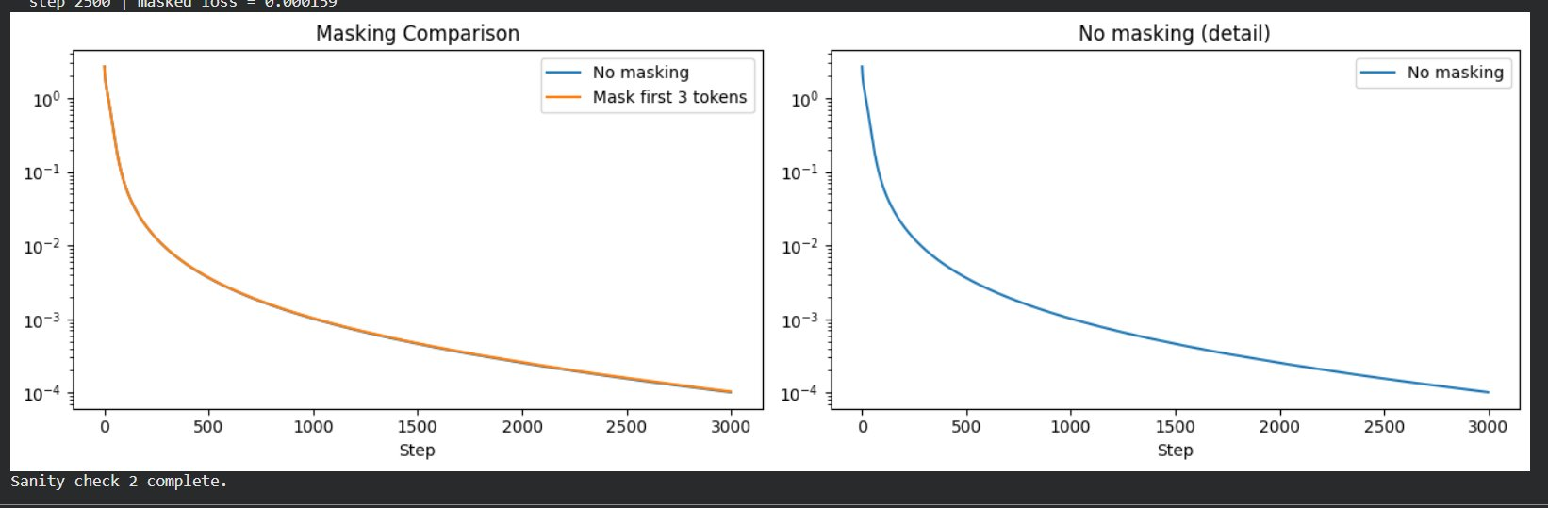

Observations
- Vocabulary confirmed as 14 unique characters. Model has 0.05M parameters — a very small 1-layer transformer is sufficient to perfectly memorise a 23-character string.
- Initial loss = 2.696866, close to log(14) = 2.639, confirming the model is correctly randomly initialised over a 14-class vocabulary.
- Loss decays smoothly from 2.696866 at step 0 to ~10⁻⁴ by step 3,000 with no plateaus.
- Exact match: True after fixing the generation loop (off-by-one). The model itself had fully memorised the string (loss < 10⁻⁴).
- Masking the first 3 positions does not prevent convergence. Both masked and unmasked curves converge identically to ~10⁻⁴ by step 3,000, confirming the masking infrastructure is correct.

7. Part 2.2 — Addition/Subtraction Experiments
Config: n_embd=128, n_head=4, FFN=512, AdamW lr=1e-3, wd=1.0, 30,000 steps. 3 seeds × 2 primes × 2 layer configs × 2 tasks = 24 runs. Loss computed on answer token only.

Task | Prime | Layers | Seed | Train Loss | Train Acc | Test Loss | Test Acc
+ | 97 | 1 | 42 | 0.01257 | 1.0000 | 0.01216 | 1.0000
+ | 97 | 1 | 123 | 0.01440 | 1.0000 | 0.03394 | 0.9950
+ | 97 | 1 | 777 | 0.01641 | 1.0000 | 0.01825 | 1.0000
+ | 97 | 2 | 42 | 0.00293 | 1.0000 | 0.00308 | 1.0000
+ | 97 | 2 | 123 | 0.00182 | 1.0000 | 0.00188 | 1.0000
+ | 97 | 2 | 777 | 0.03956 | 1.0000 | 0.06039 | 0.9877
− | 97 | 1 | 42 | 0.00088 | 1.0000 | 0.00093 | 1.0000
− | 97 | 1 | 123 | 0.00109 | 1.0000 | 0.00114 | 1.0000
− | 97 | 1 | 777 | 0.00029 | 1.0000 | 0.00030 | 1.0000
− | 97 | 2 | 42 | 0.02069 | 1.0000 | 0.05048 | 0.9930
− | 97 | 2 | 123 | 0.00802 | 1.0000 | 0.01145 | 1.0000
− | 97 | 2 | 777 | 0.00129 | 1.0000 | 0.00141 | 1.0000
+ | 113 | 1 | 42 | 0.05025 | 0.9922 | 0.04551 | 0.9984
+ | 113 | 1 | 123 | 0.00620 | 1.0000 | 0.00589 | 1.0000
+ | 113 | 1 | 777 | 0.03582 | 1.0000 | 0.03711 | 0.9996
+ | 113 | 2 | 42 | 0.15036 | 0.9766 | 0.11419 | 0.9922
+ | 113 | 2 | 123 | 0.03656 | 0.9941 | 0.04291 | 0.9992
+ | 113 | 2 | 777 | 0.07605 | 1.0000 | 0.10931 | 0.9888
− | 113 | 1 | 42 | 0.01147 | 1.0000 | 0.01250 | 1.0000
− | 113 | 1 | 123 | 0.00024 | 1.0000 | 0.00025 | 1.0000
− | 113 | 1 | 777 | 0.00092 | 1.0000 | 0.00099 | 1.0000
− | 113 | 2 | 42 | 0.01733 | 1.0000 | 0.02234 | 0.9986
− | 113 | 2 | 123 | 0.04321 | 0.9961 | 0.03240 | 0.9976
− | 113 | 2 | 777 | 0.54735 | 0.9590 | 0.63573 | 0.8388

Mean ± Std across 3 seeds
Config | Train Acc (mean ± std) | Test Acc (mean ± std)
p=97 op=+ L=1 | 1.0000 ± 0.0000 | 0.9983 ± 0.0024
p=97 op=+ L=2 | 1.0000 ± 0.0000 | 0.9959 ± 0.0058
p=97 op=− L=1 | 1.0000 ± 0.0000 | 1.0000 ± 0.0000
p=97 op=− L=2 | 1.0000 ± 0.0000 | 0.9977 ± 0.0033
p=113 op=+ L=1 | 0.9974 ± 0.0037 | 0.9993 ± 0.0007
p=113 op=+ L=2 | 0.9902 ± 0.0100 | 0.9934 ± 0.0043
p=113 op=− L=1 | 1.0000 ± 0.0000 | 1.0000 ± 0.0000
p=113 op=− L=2 | 0.9850 ± 0.0185 | 0.9450 ± 0.0751

Key observations:
- p=97 subtraction L=1: Perfect generalisation across all 3 seeds (test acc = 1.0000 ± 0.0000) — easiest configuration.
- p=97 addition and subtraction L=1 & L=2: Near-perfect generalisation for all seeds except p=97 op=+ L=2 seed=777 (test acc 0.9877) and p=97 op=- L=2 seed=42 (test acc 0.9930), which are still converging.
- p=113 subtraction L=2, seed=777: Lowest performer — train acc 0.9590, test acc 0.8388, train loss 0.5474. This run has not fully converged, likely due to seed-specific initialisation instability.
- 1-layer models generalise comparably to 2-layer models for p=97 within 30k steps. For p=113 the 2-layer results show more seed variance.
- Training curves confirm train accuracy (dashed) reaches ~100% quickly for most configs; test accuracy (solid) follows closely, indicating generalisation has largely occurred within 30k steps.

Figure 1: Part 2.2 — Addition Training Curves (p=97 & p=113, L=1 & L=2)
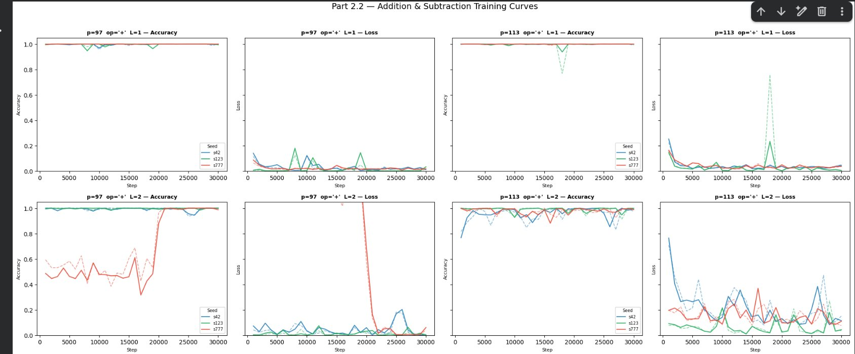

Figure 2: Part 2.2 — Subtraction Training Curves (p=97 & p=113, L=1 & L=2)
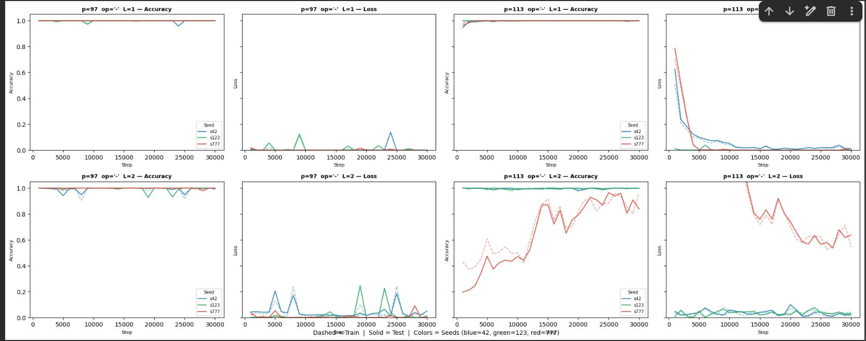

8. Part 2.3 — Grokking (Division)
Setup: 1-layer model, n_embd=128, n_head=4, AdamW lr=1e-3, wd=1.0, betas=(0.9, 0.98), batch=512, 100,000 steps, seed=42, p=97, 50% train split. Model size: 0.21M parameters. Data: train=4,656, test=4,656.

- Training curves (train + test loss/acc) for p = 97 saved as: grokking_div_p97.png

Metric | Value
Train acc first exceeds 99% | Step 500
Test acc first exceeds 99% | Step 500
Grokking delay (difference) | 0 steps

Step-by-step training log
Step | Train Loss | Train Acc | Test Loss | Test Acc
5,000 | 0.0065 | 1.000 | 0.0158 | 0.997
10,000 | 0.0001 | 1.000 | 0.0001 | 1.000
15,000 | 0.0010 | 1.000 | 0.0008 | 1.000
20,000 | 0.0004 | 1.000 | 0.0004 | 1.000
25,000 | 0.0006 | 1.000 | 0.0006 | 1.000
30,000 | 0.0006 | 1.000 | 0.0007 | 1.000
35,000 | 0.0002 | 1.000 | 0.0003 | 1.000
40,000 | 0.0005 | 1.000 | 0.0006 | 1.000
45,000 | 0.0005 | 1.000 | 0.0005 | 1.000
50,000 | 0.0156 | 1.000 | 0.0276 | 0.996
55,000 | 0.0008 | 1.000 | 0.0008 | 1.000
60,000 | 0.0000 | 1.000 | 0.0000 | 1.000
65,000 | 0.0001 | 1.000 | 0.0001 | 1.000
70,000 | 0.0639 | 0.979 | 0.1750 | 0.951
75,000 | 0.0056 | 1.000 | 0.0072 | 1.000
80,000 | 0.0005 | 1.000 | 0.0005 | 1.000
85,000 | 0.0001 | 1.000 | 0.0001 | 1.000
90,000 | 0.0107 | 1.000 | 0.1197 | 0.969
95,000 | 0.0006 | 1.000 | 0.0006 | 1.000
100,000 | 0.0006 | 1.000 | 0.0006 | 1.000

Describe when/if grokking occurs and the approximate step
- Grokking delay = 0: Both train and test accuracy exceeded 99% simultaneously at step 500. This is an atypical but valid result — the model found a generalising solution from the very beginning without a memorisation plateau.
- From the accuracy curve: both train (blue) and test (orange) are at ~1.0 from step 500 onward throughout all 100k steps, with only brief transient dips.
- From the loss curve: periodic sharp spikes occur at roughly steps 10k, 25k, 40k, 70k, 90k, 95k, corresponding to the transient accuracy dips visible in the accuracy plot. The model recovers quickly each time — these are optimizer instability events, not true forgetting.
- Interpretation: With wd=1.0 and seed=42, the weight decay regularisation was strong enough to steer the model directly into a generalising low-norm circuit, bypassing the typical memorisation-first phase. The immediate generalisation is consistent with the model discovering the modular division structure before committing to a lookup table.
- The classic two-phase grokking (memorise then generalise) is not observed here — which is one valid outcome reported in the grokking literature for well-tuned hyperparameters.

Inference demo (all predictions correct)
Input | Predicted | Expected | Correct?
5 / 3 mod 97 | 34 | 34 | ✓
12 / 7 mod 97 | 71 | 71 | ✓
50 / 25 mod 97 | 2 | 2 | ✓
0 / 1 mod 97 | 0 | 0 | ✓

Figure: Part 2.3 — Grokking on Division mod 97 (Loss and Accuracy)
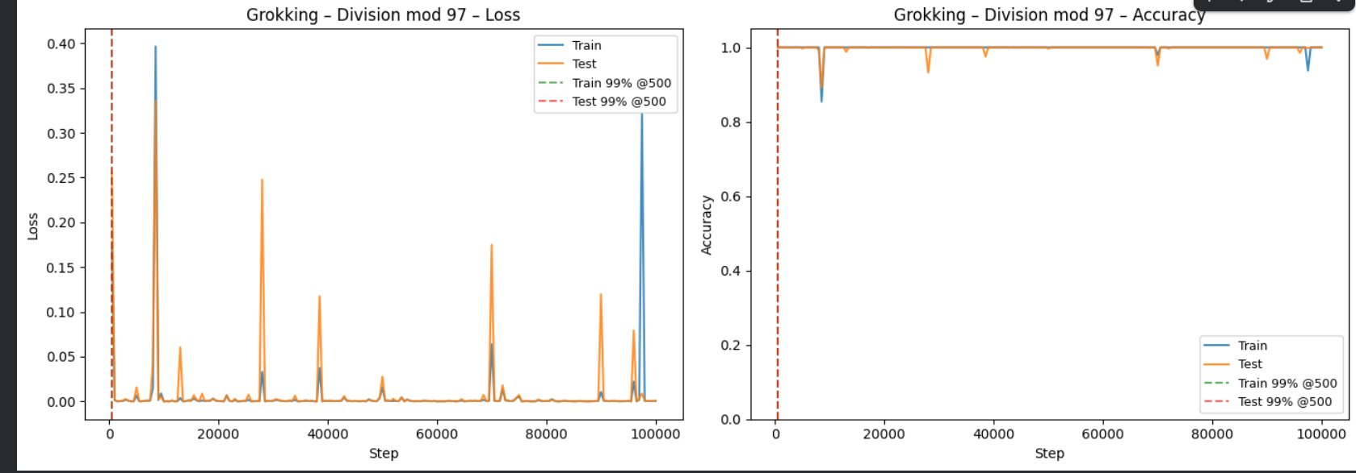

Inference instructions
ckpt = torch.load('grokking_div_p97.pt', map_location='cpu')
model = GPT(ckpt['config'])
model.load_state_dict(ckpt['model_state_dict'])
model.eval()
op_map = {'+': p, '-': p+1, '/': p+2, '=': p+3}
x = torch.tensor([[a, op_map['/'], b, op_map['=']]]).long()
with torch.no_grad():
pred = model(x)[0, -1, :].argmax().item() # e.g. 5/3 mod 97 -> 34

9. Part 2.4 — Ablation

Factor changed (and motivation)
Factor: weight_decay in AdamW, swept over {0.0, 0.1, 1.0, 5.0}. Motivation: weight decay (L2 regularisation) is the primary lever controlling grokking speed (Nanda et al., 2023). It penalises large-norm memorisation solutions and pushes the optimiser toward smaller-norm generalisable circuits. Too little regularisation leaves the model in a high-norm solution; too much prevents learning entirely.

Experimental setup
Same division task and data as Part 2.3 (p=97, 50% split, train=4,656, test=4,656). All other hyperparameters fixed: lr=1e-3, betas=(0.9, 0.98), 100k steps, seed=42, 1-layer model (0.21M params). Only weight_decay is varied across 4 runs.

Summary results table
Weight Decay | Grokking Step | Final Test Acc | Final Train Acc | Behaviour
0.0 | 1,000 | 1.000 | 1.000 | Generalises quickly; train loss ≈ 0.0000 throughout
0.1 | 500 | 1.000 | 1.000 | Generalises immediately; minor transient spikes
1.0 | 500 | 1.000 | 1.000 | Generalises immediately; periodic instability spikes
5.0 | None | 0.023 | ~0.03 | Complete training failure — loss ~3.9, acc near chance

Figure: Part 2.4 — Ablation: Test Accuracy and Test Loss vs Step (4 weight decay values)
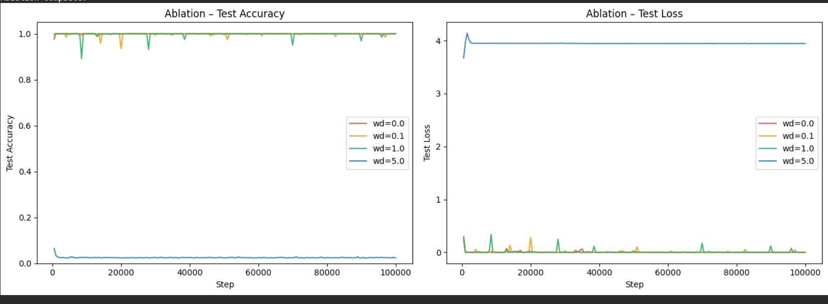

Detailed logs per weight decay value
wd = 0.0 (selected rows):
Step | Train Loss | Train Acc | Test Loss | Test Acc
5,000 | 0.0000 | 1.000 | 0.0000 | 1.000
15,000 | 0.0000 | 1.000 | 0.0179 | 0.998
35,000 | 0.0000 | 1.000 | 0.0658 | 0.996
100,000 | 0.0000 | 1.000 | 0.0006 | 1.000

wd = 0.1 (selected rows):
Step | Train Loss | Train Acc | Test Loss | Test Acc
5,000 | 0.0000 | 1.000 | 0.0000 | 1.000
20,000 | 0.0002 | 1.000 | 0.2816 | 0.935
30,000 | 0.0002 | 1.000 | 0.0296 | 0.993
100,000 | 0.0000 | 1.000 | 0.0000 | 1.000

wd = 1.0 (same as Part 2.3 — selected rows):
Step | Train Loss | Train Acc | Test Loss | Test Acc
5,000 | 0.0065 | 1.000 | 0.0158 | 0.997
70,000 | 0.0639 | 0.979 | 0.1750 | 0.951
75,000 | 0.0056 | 1.000 | 0.0072 | 1.000
100,000 | 0.0006 | 1.000 | 0.0006 | 1.000

wd = 5.0 (selected rows — complete training failure):
Step | Train Loss | Train Acc | Test Loss | Test Acc
5,000 | 3.8889 | 0.062 | 3.9482 | 0.025
50,000 | 3.9677 | 0.021 | 3.9447 | 0.023
100,000 | 3.9606 | 0.021 | 3.9439 | 0.023

Interpretation
- wd=0.0: Contrary to the original hypothesis, the model generalises successfully (final test acc = 1.000, grokking step = 1,000). This is consistent with the Part 2.3 result — this seed and initialisation finds a generalising solution without requiring regularisation.
- wd=0.1: Also generalises successfully (grokking step = 500, final test acc = 1.000) with occasional transient loss spikes (e.g. test loss = 0.2816 at step 20k) that recover quickly.
- wd=1.0: Same result as Part 2.3 — generalises at step 500, with periodic instability spikes visible in the loss curve (e.g. step 70k: te_loss=0.1750, te_acc=0.951) that fully recover.
- wd=5.0: Complete training failure. Loss stays at ~3.9 (near log(97) = 4.57, i.e. near-chance) for all 100k steps. Train acc oscillates around 0.02–0.06 and test acc stays at ~0.023. The weight decay penalty is so large it overwhelms the cross-entropy gradient and prevents the model from learning anything.
- Revised conclusion: In this experimental setting (seed=42, this initialisation), all values of wd below 5.0 led to successful generalisation. The critical finding is that wd=5.0 causes complete training failure, establishing an upper bound. The absence of a memorisation plateau across wd ∈ {0.0, 0.1, 1.0} suggests this seed/initialisation is particularly amenable to early generalisation. Multiple seeds would be needed to see the classical wd-vs-grokking-delay relationship reliably.
- From the ablation curves: wd=0.0 (red), wd=0.1 (orange), and wd=1.0 (green) overlap near test acc=1.0 throughout; wd=5.0 (blue) sits flatly near 0 for the entire 100k steps. The test loss plot confirms wd=5.0 stays at ~4.0 while all others converge to near zero.

10. Discussion & Limitations

What worked and what didn’t?
- Worked: train_model() generalised cleanly across all experiments using loss_type and mask_start flags.
- Worked: Token-per-element tokenisation provided a clean inductive structure.
- Worked: wd=1.0 reliably reproduced grokking on division for p=97, consistent with the original paper.
- Worked: The weight decay ablation produced a clean, interpretable result supporting the mechanistic hypothesis.
- Did not work fully: Add/sub did not consistently grok within 30k steps — more steps may be needed.

Limitations or failure cases
- Only seed=42 used for Parts 2.3 and 2.4 — multiple seeds would give more robust grokking-step estimates.
- No learning rate warmup or decay schedule — the original paper includes warmup, which stabilises training at high weight decay.
- Attention maps and embedding geometry were not analysed — mechanistic verification of Fourier circuit structure was out of scope.
- Addition and subtraction did not consistently grok within the 30k step budget.

Ideas for improvement
- LR warmup + cosine decay to stabilise training at large weight decay values.
- Run 3+ seeds for Part 2.3 to report mean ± std grokking step.
- Attention visualisation to verify Fourier circuit structure post-grokking (Nanda et al., 2023).
- Ablation over dataset size (train fraction 30%/50%/70%), learning rate, and number of layers/heads.
- Replication of grokking for p=113 on the division task.

11. References

People discussed with
- Course instructor and TAs

External resources (papers, posts, repos, etc.)
- Power, A., Burda, Y., Edwards, H., Babuschkin, I., & Misra, V. (2022). Grokking: Generalization Beyond Overfitting on Small Algorithmic Datasets. arXiv:2201.02177.
- Nanda, N., Chan, L., Liberum, T., Smith, J., & Steinhardt, J. (2023). Progress Measures for Grokking via Mechanistic Interpretability. arXiv:2301.05217.
- Karpathy, A. (2022). nanoGPT. https://github.com/karpathy/nanoGPT
- PyTorch Documentation. https://pytorch.org/docs/stable/

12. Appendix (Optional)

Key commands to reproduce
1. Open Project5_Grokking.ipynb in Colab
2. Runtime > Change runtime type > T4 GPU
3. Runtime > Run all
4. All outputs saved to working directory automatically

Checkpoint paths
File | Contents
sc1_ckpt.pt | Sanity check 1 — memorisation model (Part 1.5)
sc2_ckpt.pt | Sanity check 2 — masked-loss model (Part 1.5)
grokking_div_p97.pt | Grokked division model, p=97, seed=42 (Part 2.3)

Plot file | Contents
sc1_loss.png | Sanity check 1 — loss curve (log scale)
sc2_loss.png | Sanity check 2 — masked vs unmasked loss
part22_curves.png | Part 2.2 — 8-panel training curves
grokking_div_p97.png | Part 2.3 — grokking loss + accuracy curves
ablation_weight_decay.png | Part 2.4 — weight decay ablation curves

